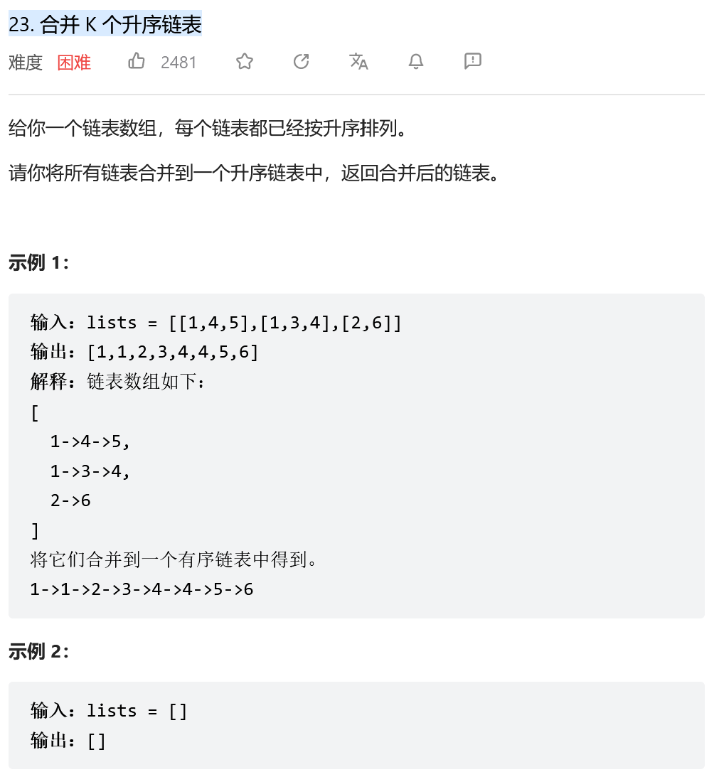
两两合并
class Solution:
def mergeKLists(self, lists: List[ListNode]) -> ListNode:
if not lists: return None
res = None #设置初始结果为空
for listi in lists: #逐个遍历 两两合并
res = self.mergeTwoLists(res, listi)
return res
def mergeTwoLists(self, l1: ListNode, l2: ListNode) -> ListNode:
dummy = ListNode(0) #构造虚节点
move = dummy #设置移动节点等于虚节点
while l1 and l2: #都不空时
if l1.val < l2.val:
move.next = l1 #移动节点指向数小的链表
l1 = l1.next
else:
move.next = l2
l2 = l2.next
move = move.next
move.next = l1 if l1 else l2 #连接后续非空链表
return dummy.next #虚节点仍在开头

归并
class Solution:
def mergeKLists(self, lists: List[ListNode]) -> ListNode:
if not lists: return None
n = len(lists) #记录子链表数量
return self.mergeSort(lists, 0, n - 1) #调用归并排序函数
def mergeSort(self, lists: List[ListNode], l: int, r: int) -> ListNode:
if l == r:
return lists[l]
m = (l + r) // 2
L = self.mergeSort(lists, l, m) #循环的递归部分
R = self.mergeSort(lists, m + 1, r)
return self.mergeTwoLists(L, R) #调用两链表合并函数
def mergeTwoLists(self, l1: ListNode, l2: ListNode) -> ListNode:
dummy = ListNode(0) #构造虚节点
move = dummy #设置移动节点等于虚节点
while l1 and l2: #都不空时
if l1.val < l2.val:
move.next = l1 #移动节点指向数小的链表
l1 = l1.next
else:
move.next = l2
l2 = l2.next
move = move.next
move.next = l1 if l1 else l2 #连接后续非空链表
return dummy.next #虚节点仍在开头

最小堆
class Solution:
def mergeKLists(self, lists: List[ListNode]) -> ListNode:
import heapq #调用堆
minHeap = []
for listi in lists:
while listi:
heapq.heappush(minHeap, listi.val) #把listi中的数据逐个加到堆中
listi = listi.next
dummy = ListNode(0) #构造虚节点
p = dummy
while minHeap:
p.next = ListNode(heapq.heappop(minHeap)) #依次弹出最小堆的数据
p = p.next
return dummy.next
